Bangladesh Army University of Engineering & Technology (BAUET)

Qadirabad, Natore-6431

**Department of**

**Computer Science and Engineering (CSE)**

**Project Book**

**Course Code:** CSE-3104

**Course Title:** Software Engineering and Information System Sessional

**Submission Date:** 03-11-2022

|  |  |
| --- | --- |
| **Submitted By** | **Submitted To** |
| **Name:**  Fahmida Rahman Moumi | Md. Nazmus Salehin |
| **ID:** 20104001 | Lecturer |
| **Name:**  Md. Tanvir Ahmed Tagim | Dept. of CSE, BAUET |
| **ID:** 20104007 |  |
| **Name:**  Amrin Nahar | Mst. Irin Sultana |
| **ID:** 20104009 | Lecturer |
| **Name:** Gourob Roy | Dept. of CSE, BAUET |
| **ID:** 20104027 |  |
| **Name:**  Mst. Bilkis Khatun |  |
| **ID:** 20104031 |  |
| **Name:** Md. Arik Rayhan |  |
| **ID:** 20104033 |  |
| **Department:** CSE |  |
| **Batch:** 11th |  |
| **Session:** 2020-2021 |  |

**ABSTRACT**

The technological development and impact of computers and the internet on our lives that has been verified over time affected various sectors of activity. And almost every task today is being run through computers. Getting information and quickly turning it into a product that consumers want is the essential key to staying in business and all of this is done nowadays using computers and applications or information systems. And the education system is undeniably the backbone of society, it focuses on preparing young talents for the future. The main objective of this project is to provide results to the students in a simple way. Result Management System is basically a system which provides the report of students. In the BAUET Result Management System we include a feature in which we define Top student as per their percentage basis. In the all-student information report, we highlight student as per their Marks total and percentage. Like the all-student report in the pass student report and in the failure Student report also contain same feature. In add marks information form we include a condition that is you cannot Add marks of student more than once. This can be achieved with web development technologies like HTML, CSS, PHP, JavaScript and using the database MySQL. The faculty can view the overall performance of the students in the semester examinations subject wise. The visualization of the overall results according to the subject (The percentage of pass and fail in a particular subject) can be done using fusion charts.

|  |  |  |
| --- | --- | --- |
| **List of contents** | | |
| **Chapter** | **Title** | **Page No.** |
|  | Abstract |  |
|  | List of contents |  |
|  | List of figures |  |
|  | List of tables |  |
|  |  |  |
| **1** | **INTRODUCTION** | **1-2** |
|  | 1.1 Introduction | 1 |
|  | 1.2 Background of Project | 1 |
|  | 1.3 Project Aims and Objectives | 1-2 |
|  | 1.4 Conclusion | 2 |
|  |  |  |
| **2** | **PLANNING** | **3-5** |
|  | 2.1 Introduction | 3 |
|  | 2.2 Scope of our works | 3 |
|  | 2.3 Methodology | 3-4 |
|  | 2.4 Flow Chart | 4-5 |
|  | 2.5 Conclusion | 5 |
|  |  |  |
| **3** | **ANALYSIS** | **6-8** |
|  | 3.1 Introduction | 6 |
|  | 3.2 Question and Answering | 6-8 |
|  | 3.3 Conclusion | 8 |
|  |  |  |
| **4** | **DESING** | **9-14** |
|  | 4.1 Introduction | 9 |
|  | 4.1.1 UML Diagram | 9-10 |
|  | 4.1.2 Use Case Diagram | 10-11 |
|  | 4.2 Description on UML and Use Case Diagram | 12-14 |
|  | 4.3 Conclusion | 14 |
|  |  |  |
| **5** | **IMPLEMENTATION** | **15-20** |
|  | 5.1 Introduction | 15 |
|  | 5.2 Graphical Representation of BAUET Result System | 15-20 |
|  | 5.3 Conclusion | 20 |
|  |  |  |
| **6** | **TESTING & INTEGRATION** | **21-24** |
|  | 6.1 Introduction | 21 |
|  | 6.2 Black Box Testing | 21-22 |
|  | 6.3 White Box Testing | 22-24 |
|  | 6.4 Conclusion | 24 |
|  |  |  |
| **7** | **CONCLUSION** | **25** |
|  | 7.1 Introduction | 25 |
|  | 7.2 About | 25 |
|  | 7.3 Future Work | 25 |
|  | 7.4 Conclusion | 25 |

|  |  |  |
| --- | --- | --- |
|  | **List of figures** |  |
| **Figure No.** | **Title** | **Page No.** |
| 2.3.1 | Student Flowchart Diagram | 4 |
| 2.3.2 | Admin Flowchart Diagram | 5 |
| 4.2.1 | UML Diagram on BAUET Result System | 12 |
| 4.2.2 | Use Case Diagram for BAUET Result System | 13 |
| 5.2.1 | Login Page | 15 |
| 5.2.2 | Admin Dashboard Page | 16 |
| 5.2.3 | Create New Department | 16 |
| 5.2.4 | Create New Course | 17 |
| 5.2.5 | Add New Faculty | 17 |
| 5.2.6 | Per Semester Result | 18 |
| 5.2.7 | Final Result | 18 |
| 5.2.8 | Student login | 19 |
| 5.2.9 | Student Dashboard | 19 |
| 5.2.10 | Student Course | 20 |
| 5.2.11 | Grade Criteria | 20 |
| 6.2.1 | Wrong User name and password | 21 |
| 6.2.2 | Adding student with same ID | 22 |
| 6.2.3 | Computing the same result twice | 22 |
|  |  |  |

|  |  |  |
| --- | --- | --- |
|  | **List of Table** |  |
| **Table No.** | **Title** | **Page No.** |
| 6.1 | Login Test Case | 22-23 |
|  |  |  |

**Chapter 1**

**Introduction**

* 1. **Introduction**

Result Management System is basically a system which provides the report Of students..In the Result Management System we include a feature in which we define Top student as per their  percentage basis.In the all student information report we highlight student as per their Marks totaland percentage. Like the all student report in the pass student report and in the fail Student reportalso contain same feature.In add marks information form we include a condition that is you cannot Add marks of student more than once.

* 1. **Background of Project**

The traditional result of BAUET works by manually creating the result of each student.The students’ results are generated through a spreadsheet application and then printed on a paper, attached to a wall for declaration and then stored. The process is that teacher take marks of each student based on OBE curriculum and then manually calculate the results of each student. Then their result is stored in a spreadsheet and given to the account office. Moreover, BAUET follows OBE based curriculum which is follows these rules: The total performance of a student in a given course is based on a scheme of continuous assessment. For theory course this continuous assessment is made through a set of quizzes, class tests, observations/ class participation and class attendance, homework assignment and a semester final examination. The assessment in laboratory courses is made by evaluating performance of the student at work during the class, viva-voce during laboratory hours and quizzes. Each course has a certain number of credits, which describes its corresponding weightages. A letter grade with a specified number of grade points is awarded in each course for which a student is registered. A student's performance is measured by the number of credits completed satisfactorily and by the weighted average of the grade points earned. A minimum Grade Point Average (GPA) is essential for satisfactory progress.A minimum number of earned credits also have to be acquired in order to qualify for the degree. Letter grades and corresponding grade points will be awarded in accordance with the provisions (as per University Grant Commission-UGC grading system). One of the popular universities in Bangladesh is DIU so here we are addressing their result system. In addition to class work, home assignments, term papers, project works, case studies, quizzes and weekly tests. There are three compulsory examinations in each semester for each course such as First Term, Mid-Term and Final Examination. The grade shall be determined and given by the teacher who is responsible for the course, according to overall performances in all the examinations.

* 1. **Project Aims and Objectives**

The main object of the BAUET Result Management System is to manage the details of Results, Progress, student, Course, and Exam. It manages all the information about Results, Activity CO (Course Outcome), PO (Program Outcome), etc. The project is totally built at the administrative end and thus only the administrator is guaranteed access. The purpose of the project is to build an application program to reduce the manual work for managing the result, progress, Activity, and Student. It tracks all the details

* Integration of all records of Exam.
* Manage the information of result.
* Manage the information of course.
* Monitoring the information and transactions of course.
* Searching facilities based on ID and Course Code.
* Keep record of the students.
* Minimize the manual paper work.

.

* 1. **Conclusion**

Our project is only a humble venture to satisfy the needs to manage their project work. Several user-friendly coding has also adopted. This package shall prove to be a powerful package in satisfying all the requirements of the school. The objective of software planning is to provide a frame work that enables the manger to make reasonable estimates made within a limited time frame at the beginning of the software project and should be updated regularly as the project progresses.

**Chapter 2**

**PLANNING**

**2.1 Introduction**

Planning is the most basic of all managerial functions which involves establishing goals, setting out objectives and define the methods by which these goals and objectives to be attained. It is therefore a relation approach to achieving important documents in the overall planning, monitoring and implementation of a project. The Project Manager creates the project plan during the NPMS planning phase after extensive analysis, based on input from the project team and key stakeholders. The purpose of this document is to define how to the project is to be executed, monitored and controlled by the project team. It details how the Project management Team will manage the Project.

**2.2 Scope of our works**

We plan to develop this project by using this will reduce the need for human resources and save a lot of time. The purpose of the BAUET Result system is to automate the existing manual system with the help of computerized equipment and full-fledged computer software, fulfilling their requirements valuable data information can be stored for a longer period with easy accessing and manipulation of the same. The required software and hardware are easily available and easy to work with. Student Result System, as described above, can lead to an error-free, secure, reliable and fast system. It can assist the user to concentrate on their other activities rather than on record keeping. Thus, it will help the organization in better utilization of resources. The organization can maintain computerized records without redundant entries. That means that one need not be distracted by information. Student Result web System, as described above, can lead to an error-free, secure, reliable and fast management system. It can assist the user to concentrate on them rather than on record keeping. Thus, it will help the organization in better utilization of resources. The organization can maintain computerized records without redundant entries. That means that one need not be distracted by information that is not relevant while being able to reach the information. The main objective was to enhance and automate the management and declaration of students results using a computerized system. A well-defined, efficient, controlled and managed information system or software based on web technology storing, processing and providing information through the internet.

**2.2 Methodology**

Step 1: At first User have to enter the website.

Step 2: Then user have to login.

Step 3: Then the system will check if the user is Teacher or Student.

Step 4: The teacher will be able to modify marks and subject and profile.

Step 5: The user will be able to view result and modify profile.

Step 6: Then they will exit.

**2.4 Flow Chart**

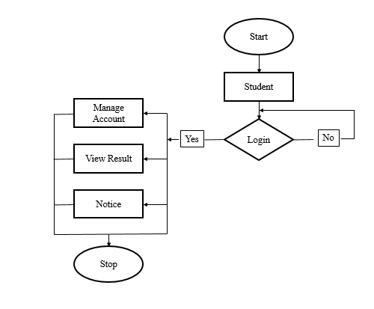

**Fig-01: Student Flowchart Diagram**

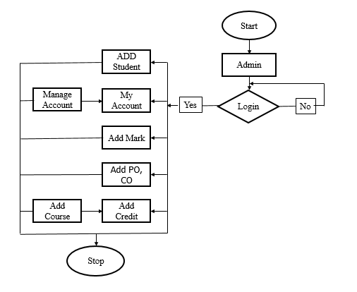

**Fig-02: Admin Flowchart Diagram**

**2.5 Conclusion**

The Planning process of any organization is essential to the overall success of the company. All levels of planning must do their part to incorporate situation analysis, alternative goals and plans, goals and plan evaluation, goal and plan section, implementation, and monitor.

**Chapter 3**

**ANALYSIS**

**3.1 Introduction**

Systems analysis is a problem-solving technique that decomposes a system into its component pieces for the purpose of studying how well those component parts work and interact to accomplish their purpose. According to the Merriam-Webster dictionary, systems analysis is the process of studying a procedure or business in order to identify its goals and purposes and create systems and procedures that will achieve them in an efficient way. Analysis and synthesis, as scientific methods, always go hand in hand; they complement one another. Every synthesis is built upon the results of a preceding analysis, and every analysis requires a subsequent synthesis to verify and correct its results. This field is closely related to requirements analysis or operations research. It is also an explicit formal inquiry carried out to help someone (referred to as the decision-maker) identify a better course of action and make a better decision than she might otherwise have made.

|  |  |  |
| --- | --- | --- |
| **Name:** Aroni Saha Prapty | **Designation:** Lecturer | **Institution:** BAUET |

**Question No-01:** What grading system does BAUET follow?

**Ans:** Letter grades and corresponding grade points will be awarded in accordance with the provisions (as per the University Grant Commission-UGC grading system)

Shown below:

|  |  |  |
| --- | --- | --- |
| Numerical Score | Letter grade | Grade Point |
| 80% and above | A+ | 4.00 |
| 75% to below 80% | A | 3.75 |
| 70% to below 75% | A- | 3.50 |
| 65% to below 70% | B+ | 3.25 |
| 60% to below 65% | B | 3.00 |
| 55% to below 60% | B- | 2.75 |
| 50% to below 55% | C+ | 2.50 |
| 45% to below 50% | C | 2.25 |
| 40% to below 45% | D | 2.00 |
| Below 40% | F | 0.00 |

**Question No-02:** What is the requirement for giving referred exam?

**Ans:** If a student gets a grade point of 0.00 then he will be able to give referred exam.

**Question No-03:**  What is the requirement for giving an improvement exam?

**Ans:** If a student gets grade points between 2.00 to 3.00 then he will be able to give an improvement exam.

**Question No-04:**  Can a student get a GPA above 3.00 after giving an improvement exam?

**Ans:** Yes, he gets all the marks that he got in the improvement exam.

**Question No-05:**  How to calculate GPA?

Ans: Grade Point Average (GPA) is the weighted average of the grade points obtained from all the courses passed/completed by a student. For Example, if a student passes/completes ‘n’ courses in a semester having credits of C1, C2.........., Cn and his/her grade points in these courses are G1, G2,............., Gn respectively,

GPA= $\sum_{i=1}^{n}{Ci*Gi}$/ $\sum_{i=1}^{n}{Ci}$

**Question No-06:**  How to calculate CGPA?

Ans: The Cumulative Grade Point Average (CGPA) is the weighted average of the GPA obtained in all the semesters passed/completed by a student. For example, if a student passes/completes ‘n’ semester having total credits of TC1,TC2.........., TCn and his/her GPA in these semesters are GPA1, GPA2 ......GPAn respectively then,

CGPA= $\sum_{i=1}^{n}{TCi*GPAi/\sum_{i=1}^{n}{TCi}}$

**Question No-07:**  What is PO?

**Ans:** Program Outcomes (POs) represent the knowledge, skills and attitudes the students should have at the end of a four-year engineering program. Based on the suggestion of the Board of Accreditation for Engineering and Technical Education (BAETE), Bangladesh, the Bachelor of Computer Science and Engineering (CSE) program will have the following learning outcomes: Engineering Knowledge, Problem Analysis, Design/development of solutions,

The investigation, Modern tool usage, The engineer and society, Environment and sustainability, Ethics, Individual work and teamwork, Communication, and Life-long learning.

**Question No-08:**  What is CO?

**Ans:** Course Outcomes are the statements that help the learners to understand the reason for pursuing the course and help them to identify what they will be able to do at the end of the course

**Question No-09:** Can a student see their results without paying their dues?

**Ans:** No, the students have to pay their semester fees and hall fee to see their results.

|  |  |  |
| --- | --- | --- |
| **Name:** Subrata Kumer Paul | **Designation:** Lecturer | **Institution:** BAUET |

**Question No-01:** Do you face any difficulties in the manual result processing system?

**Ans:** Inconsistency in data entry, chances for errors, mis keying information, time-consuming and costly to produce reports, duplication of data entry.

**Question No-02:** What's your opinion on the online result system?

**Ans:** This is the most obvious of an online result management system. Generally, the traditional paper-based result management system takes time to collect the internal assessment results then manually calculate and input them into the system and wait until the reports are printed. However, with an online system, the test results are calculated automatically which will helpful for us

**Question No-03:** What will you prefer for making results between manual and automatic systems?

**Ans:** I will prefer for making results clear and complete understanding with an automatic system.

**Question No-04:** What are the top three requirements you admire in our result processing system?

**Ans:** 1. Error-Free Results

2. Bias-Free Checking of Marks

3. Update Data Anytime

|  |  |  |
| --- | --- | --- |
| **Name:** Sourov Kumar | **Designation:** Student | **Institution:** BAUET |

**Question No-01:**  What would you like in our system?

**Ans:** I would like to have the ability to private my result. As currently, the management system shows the results to everyone publicly.

**Question No-02:**  What types of facilities do you want to see in the resulting system?

**Ans:** I would like to see my mark sheet without the extra payment

|  |  |  |
| --- | --- | --- |
| **Name:** Upal Mondal | **Designation:** Student | **Institution:** BAUET |

**Question No-01:**  What's your opinion on the online result system?

**Ans:** The immediate results not only help to reduce the stress of waiting for results. When we receive our marks and scores, the faster results also help us to realize our errors and seek improvement before the next text.

**Question No-02:**  What types of facilities do you want to see in the resulting system?

**Ans:** I want to see all semester results on one page. And the facilities to download the current semester result from the website after completing payment.

|  |  |  |
| --- | --- | --- |
| **Name:** Saiful Islam | **Designation:** Student | **Institution:** BAUET |

**Question No-01:**  What's your opinion on the online result system?

**Ans:** The online result system is a very good initiative as it will save time and resources by a large amount.

**Question No-02:**  What types of facilities do you want to see in the resulting system?

**Ans:** I want to see an analysis report on my result so that I can focus on my weakness.

**Conclusion**

From a proper analysis of positive points and constraints on the component, it can be safely concluded that the product is a highly efficient WEB based component. This application is working properly and meeting to all user requirements. This component can be easily plugged in many other systems.

**Chapter 4**

**DESIGN**

**4.1: Introduction**

Findings of the requirement analysis phase were taken into consideration when designing the system. A good design leads to a successful implementation. This chapter describes the desired features and the operations of the system in detail, using screen layouts, process diagrams, and database diagrams. While the software is being conceptualized, a plan is chalked out to find the best possible design for implementing the intended solution. [1] Out of the following alternative solutions, developing a web-based application was selected as the best possible solution to implement the system.

**4.1.1: UML Diagram**

The UML (Unified Modeling Language) diagram depicts a static view of an application. It represents the types of objects residing in the system and the relationships between them. A class consists of its objects, and also it may inherit from other classes. A class diagram is used to visualize, describe, document various aspects of the system, and also construct executable software code. It shows the attributes, classes, functions, and relationships to give an overview of the software system. It constitutes class names, attributes, and functions in a separate compartment that helps in software development. Since it is a collection of classes, interfaces, associations, collaborations, and constraints, it is termed as a structural diagram.

The main purpose of class diagrams is to build a static view of an application. It is the only diagram that is widely used for construction, and it can be mapped with object-oriented languages. It is one of the most popular UML diagrams. It analyses and designs a static view of an application. It describes the major responsibilities of a system. It is a base for component and deployment diagrams. It incorporates forward and reverse engineering.

The class diagram is made up of three sections:

* **Upper Section:** The upper section encompasses the name of the class. A class is a representation of similar objects that share the same relationships, attributes, operations, and semantics.
* **Middle Section:** The middle section constitutes the attributes which describe the quality of the class. The attributes have the following characteristics:
  + The attributes are written along with its visibility factors, which are public (+), private (-), protected (#), and package (~).
  + The accessibility of an attribute class is illustrated by the visibility factors.
  + A meaningful name should be assigned to the attribute, which will explain its usage inside the class.
* **Lower Section:** The lower section contains methods or operations. The methods are represented in the form of a list, where each method is written in a single line. It demonstrates how a class interacts with data.

In UML, relationships are of five types:

* **Dependency:** A dependency is a semantic relationship between two or more classes where a change in one class causes changes in another class. It forms a weaker relationship.  
  In the following example, Student Name is dependent on the Student ID.
* **Generalization:** A generalization is a relationship between a parent class (superclass) and a child class (subclass). In this, the child class is inherited from the parent class.  
  For example, The Current Account, Saving Account, and Credit Account are the generalized form of Bank Account.
* **Association:** It describes a static or physical connection between two or more objects. It depicts how many objects are there in the relationship.  
  For example, a department is associated with the university.
* **Aggregation:** An aggregation is a subset of association, which represents a relationship. It is more specific than association. It defines a part-whole or part-of relationship. In this kind of relationship, the child’s class can exist independently of its parent’s class.
* **Composition:** The composition is a subset of aggregation. It portrays the dependency between the parent and its child, which means if one part is deleted, then the other part also gets discarded. It represents a whole-part relationship.

**4.1.2: Use Case Diagram:**

The Use Case model is defined as a model which is used to show how users interact with the system to solve a problem. As such, the use case model defines the user's objective, the interactions between the system and the user, and the system's behavior required to meet these objectives. Various model elements are contained in use-case models, such as actors, use cases, and the association between them.

We use a use-case diagram to graphically portray a subset of the model in order to make the communication simpler. There will regularly be a numerous use-case diagram which is related to the given model, each demonstrating a subset of the model components related to a specific purpose. A similar model component might appear on a few use-case diagrams; however, each use-case should be consistent.

If, to handle the use-case model, tools are used then this consistency restriction is automated so that any variations to the component of the model (changing the name, for instance) will be reflected automatically on each use-case diagram, which shows that component. Packages may include a use-case model, which is used to organize the model to simplify the analysis, planning, navigation, communication, development, and maintenance.

There are various components of the basic model:

* **Actor**: Usually, actors are people involved with the system defined on the basis of their roles. An actor can be anything such as human or another external system.

### **Use Case:** The use case defines how actors use a system to accomplish a specific objective. The use cases are generally introduced by the user to meet the objectives of the activities and variants involved in the achievement of the goal.

### **Associations:** Associations are another component of the basic model. It is used to define the associations among actors and use cases they contribute in. This association is called communicates-association.

### **Subject:** The subject component is used to represent the boundary of the system of interest.

### **Use-Case Package:** We use the model component in order to structure the use case model to make simpler the analysis, planning, navigation, and communication. Suppose there are various actors or use cases. In that case, we can also use use-case packages in order to further structure the use-case model in much the similar way we use directories or folders to organize the information on our hard-disk. For various reasons, we divide the use-case model into the use-case packages, containing.

### To help parallel development by partitioning the problem into bite-sized parts.

### To improve communication with various stakeholders by making packaging containing actors, use cases and related to the specific stakeholder.

### **Generalizations:** Generalizations mean the association between the actors in order to help re-use of common properties.

### **Dependencies:** In UML, various types of dependencies are defined between use cases. In particular <<include>> and <<extend>>. We use <<include>> dependency to comprise shared behavior from an included use case into a base use case to use common behavior. We use <<extend>> dependency to include optional behavior from an extended use-case into an extended use case.

**4.2: Description on UML and Use Case Diagram:**

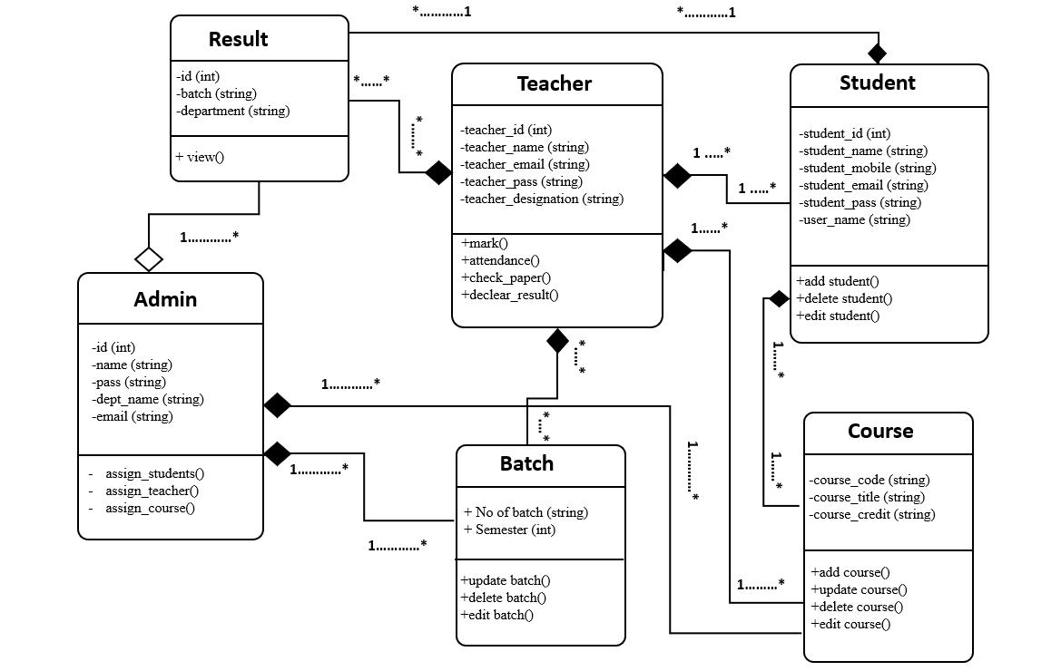**4.2.1: UML Diagram**

Figure- 4.2.1: UML Diagram on BAUET Result System

The UML diagram of BAUET Result Management System shows the graphical notation used to construct and visualize object-oriented systems. The class diagram describing the result system is given below.

The Admin will have id, password and Admin consists of multiple classes for Batch and Course with composite relationship and multiplicity (one to many) with Batch and Course. The Admin also consists of Result class of students with aggregation relationship and multiplicity (one to many) with Result. Admin can assign Teachers, Students, Batches. If Admin removes the result of any student, and even if one student drops out, the Admin still exists.

In the Teacher class all the teachers will have their necessary information to login and process their work. They will have teacher id, teacher email, teacher password as the attributes for the class. The Teacher class consists of classes for Result, Student, Batch and Course with composite relationship and multiplicity (many to many) with Batch and Course. Teacher also consists of Result and Student class with composite relationship and multiplicity (one to many) with Result and Student. Teachers can add marks, percentage of attendance, marks after checking papers and declare the result of students.

And the **Student** class consists of classes for Course and Result with composite relationship and multiplicity (one to many) with Course and Result. Students can view and download results using the authentic information of their student_id, student_name, student_mobile number, student_email, student_pass, user_name.

**4.2.2: Use Case Diagram**

**Figure- 4.2.2:** Use case Diagram for BAUET Result System

ThisUse-case diagram provides an outline related to all components in the BAUET Result Management System. Use-case diagram helps to define the role of Admin, Teachers, and Students as actors. The ovals in the use-cases fill up with the verb which have to label the ovals in order to represent the functions of the system. Such as login, register, manages, add users etc. With the simple line representing relationships between an actor and use cases. For relationships between use-case, the arrows which are labeled either "extends" or "uses". The "extends" relationship shows the alternative options under the specific use case. The "uses" relationship shows that single use-case is required to accomplish a job.

The admin will be able to manage the semester and generate course codes. He can also add new teachers and students to the system.

The teacher can manage semesters, manage courses and add record test or exam scores. But he must be logged in to do so.

And here the student can registration by creating account, register courses and view or print his result. Which all requires him to log in to the system. There is also an optional feature called drop course for the student.

And the actor as Exam Office relates to generate master sheet and showing results.

The relationship between Admin login use-case to manage course and generate registration code use-case are <<include>> and with generate or print Master sheet use-case the relationship is <<extend>>.

The relationship between User login use-case to register course and print transcription, exams scores use-cases are connected with <<include>> relation.

The rectangle defines the boundaries of the system, which includes use-cases. And need to put the actors outside the system's boundaries.

**4.3: Conclusion**

BAUET Result System is an online website and can be used at any place, any time and by any student or faculty. This application will avoid calculation and simplify the process of visualizing results by students as well as faculty. The main objective was to enhance and automate the management and declaration of student’s results using a computerized system. A well-defined, efficient, controlled and managed information system or software based on web technology storing, processing and providing information through the internet.A simple and complete UML and Use Case diagram should be articulated. A use case diagram should represent the most significant interaction among the multiple interactions. At least one module of a system should be represented by the use case diagram. If the use case diagram is large and more complex, then it should be drawn more generalized.

**Chapter 5**

**IMPLEMENTATION**

**5.1 Introduction**

BAUET Result System is a web- based tool that primarily focuses on delivering results tostudents and instructors. The student checks their separate outcomes using their university registered recognition ids, as well as their grades and semester percentages of that particular semester. The student accessing their results through university site is more convenient and the faculty can easily analysis the pass and failure of a particular subject. The system is divided into three modules- Student, Faculty and Administrator. The student using his roll number can view his results and the faculty using the joining year and the subject name and view the analysis of pass and failure count in the selected subject . The administrator uploads the results file to the database by converting the file to sql format(.sql) from the PDF format(.pdf).The admin is provided with the privileges to modify the student results by updating the results during the changes in supplementary or revaluation examination. The update of any current score is to done by the administrator.

**5.2 Graphical Representation of House Rent Management System:**

Graphical representation of our system is shown below:

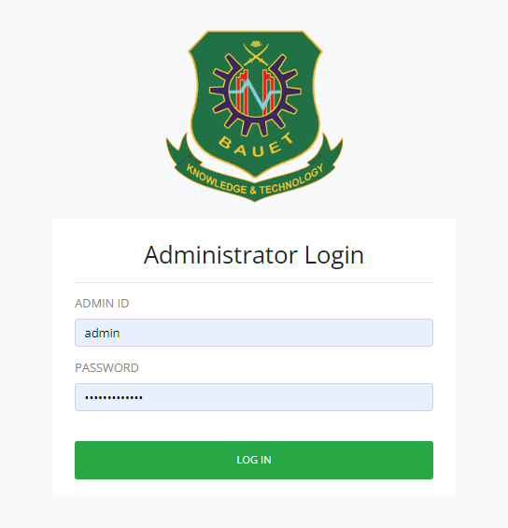

**Figure 01: Login Page**

Here, Admin login with Username and Password. The login page allows a user to gain access to an application by entering their username and password or by authenticating using a login page.

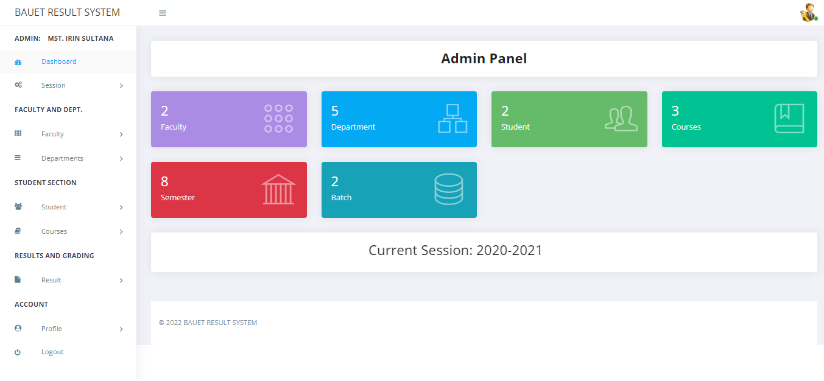

**Figure 02: Admin Dashboard Page**

An admin dashboard is one of the core components of a BAUET Result System. here is the list of features of result system. It allows the admin to quickly access the state of the site and decide what actions need to be taken.

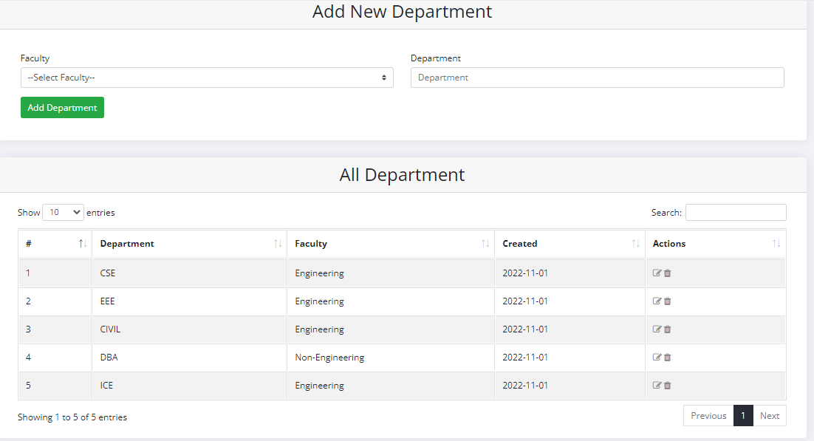

**Figure 03: Create new Department**

Admin dashboard in department page. Here admin can add department and delete. Admin enter department name add click enter who successfully enter department. Also, admin edit it.

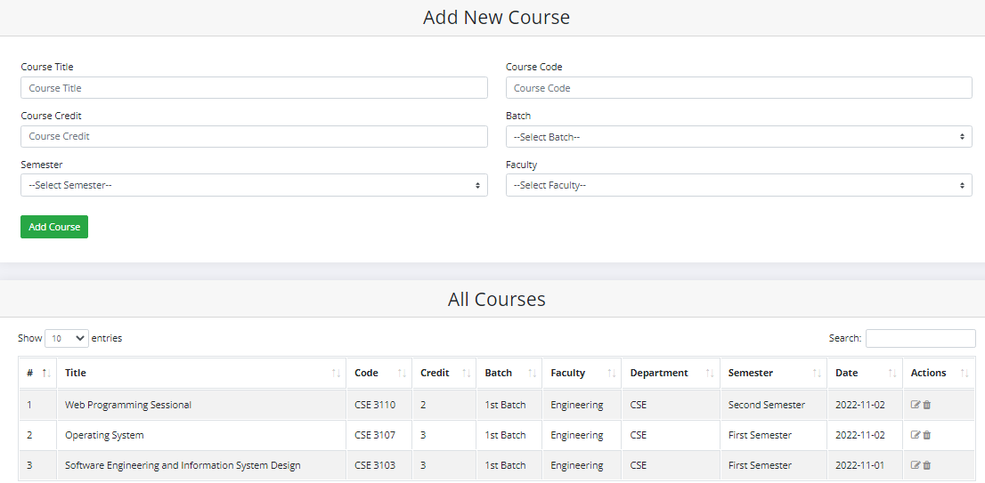

**Figure 04: Create new courses**

Here is a course page. Admin control it. Add course code, title, dept.name, credit who help create a new course, admin can edit it.

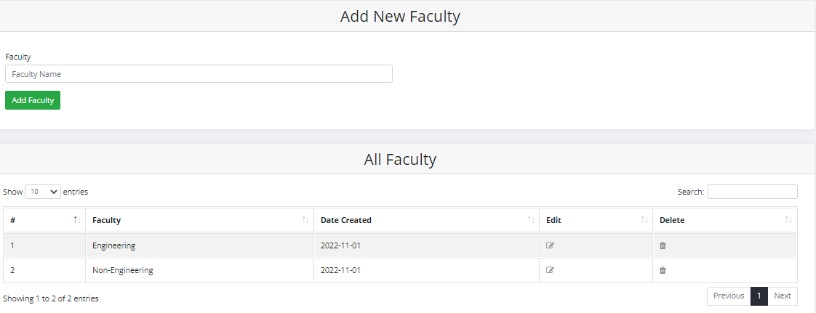

**Figure 05: Add New Faculty**

Admin dashboard in Faculty page. Here admin can add Faculty and delete. Admin enter Faculty name add click enter who successfully enter Faculty. Also, admin edit it.

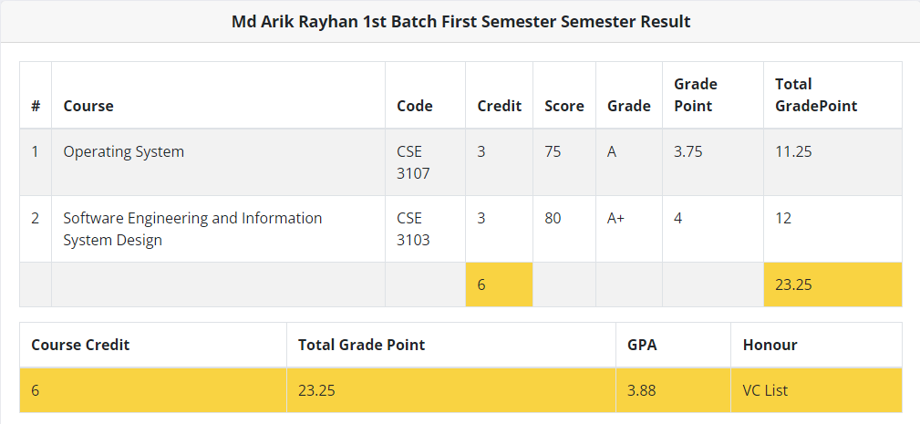

**Figure 06: Per Semester Result**

Here is a per semester result distribute page. Here calculate result GPA**.** Grade calculate process on the hand of teacher who control it.

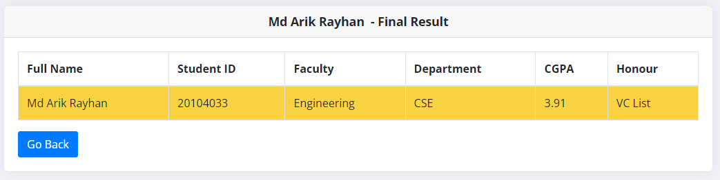

**Figure 07: Final Result**

Here is a per semester result distribute page. Here calculate result CG. Total CG calculate process on the hand of teacher who control it.[3]

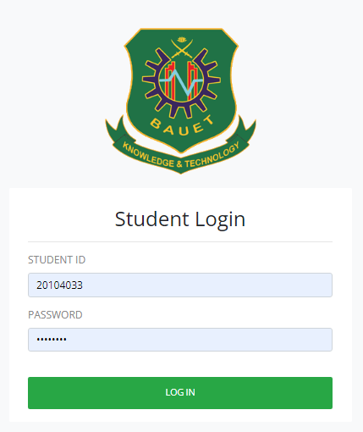

**Figure 08: Student Login**

Here, Student login with Username and Password. The login page allows a user to gain access to an application by entering their username and password or by authenticating using a login page.

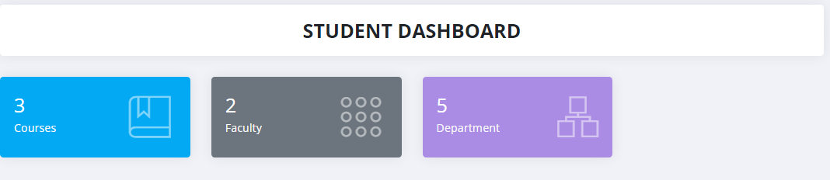

**Figure 09: Student Dashboard**

Here is a student dashboard distribute page.

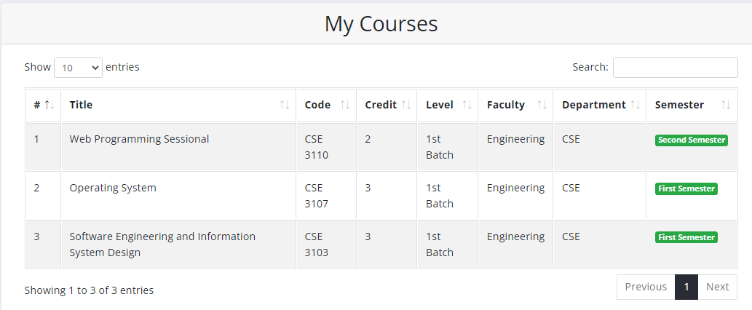

**Figure 09: Student Courses**

Here is a student courses distribute page. Student Enrol the courses per semester.

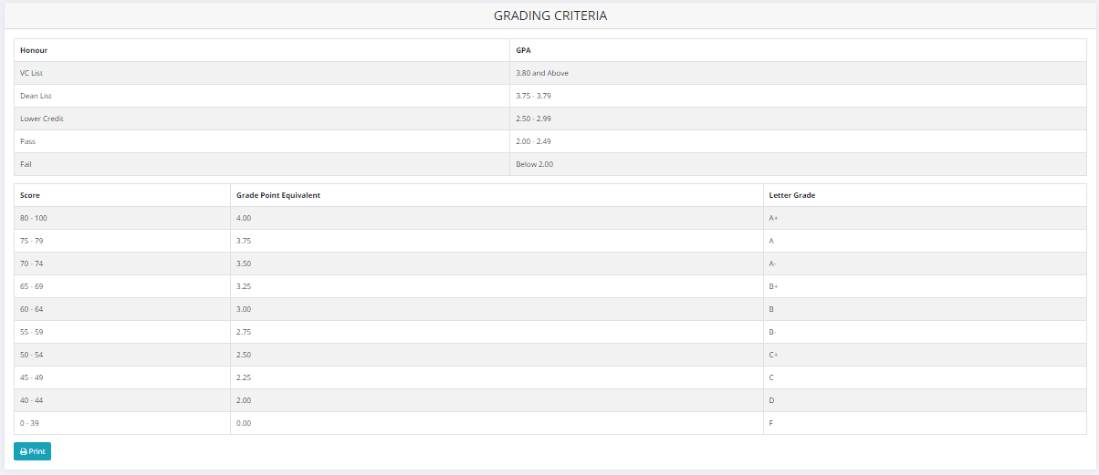

**Figure 10: Grade Criteria**

Here is a grade distribute page. Here calculate result CG, GPA**.** Grade calculate process on the hand of teacher who control it.

**5.3 Conclusion**

BAUET Result Systems make faculty jobs more accessible by giving them an easy place to find and sort information. This system allows teachers and student managers to follow with their student engagement. The idea is to create a scenario that makes the lives of administration and teachers easier.

**Chapter 6**

**Testing & Integration**

**6.1 Introduction**

Software testing can be stated as the process of verifying and validating whether a software or application is bug-free, meets the technical requirements as guided by its design and development, and meets the user requirements effectively and efficiently by handling all the exceptional and boundary cases. The process of software testing aims not only at finding faults in the existing software but also at finding measures to improve the software in terms of efficiency, accuracy, and usability. It mainly aims at measuring the specification, functionality, and performance of a software program or application. There are 2 method to test any software

1. Black Box Testing
2. White Box Testing

**6.2 Black Box Testing**

**Black Box Testing** is a software testing method in which the functionalities of software applications are tested without having knowledge of internal code structure, implementation details and internal paths. Black Box Testing mainly focuses on input and output of software applications and it is entirely based on software requirements and specifications. It is also known as Behavioral Testing.

**Some figure of Black Box Testing:**

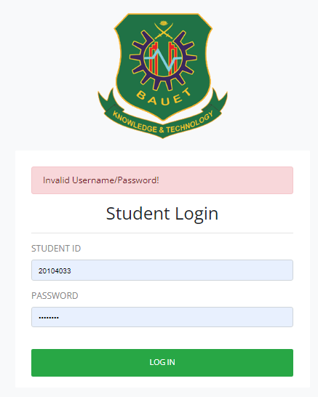

**Figure 11: Wrong User name and Password**

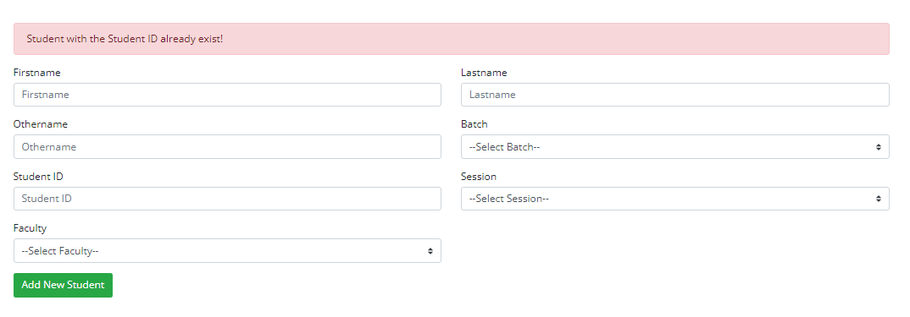

**Figure 2: Adding Student with same ID**

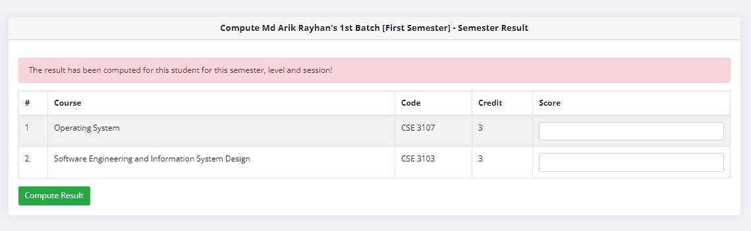

**Figure 3: Computing the same result twice**

**6.3 White box Testing**

**White Box Testing** is a testing technique in which software’s internal structure, design, and coding are tested to verify input-output flow and improve design, usability, and security. In white box testing, code is visible to testers, so it is also called Clear box testing, Open box testing, Transparent box testing, Code-based testing, and Glass box testing.[1]

Test cases and expected results are displayed below:

|  |  |  |  |  |
| --- | --- | --- | --- | --- |
| Test Case No | Test Description | Testing Steps | Test Data | Expected Result |
| TC 01 | Validate input details in the login form | 1. Enter the user’s name according to  test data  2. Enter the password  according to  test data  3. Press login  button | Blank user name & blank password | Error message “Both Email and password are Empty” |
| TC 02 | Blank user name & given a password | Error message “Empty Email” |
| TC 03 | Given user name & blank Password | Error message “Empty password” |
| TC 04 | Wrong email and correct password | Error message “Invalid Email address or Password” |
| TC 05 | Correct email and wrong password | Error message “Invalid Email address or Password” |
| TC 06 | Both incorrect email & password | Error message “Invalid Email address or Password” |
| TC 07 | Correct email & correct password | Redirect to Dashboard |

Table 6.1: Login test case

UNIT TESTING is a type of software testing where individual units or components of a software are tested. The purpose is to validate that each unit of the software code performs as expected. Unit Testing is done during the development (coding phase) of an application by the developers. Unit Tests isolate a section of code and verify its correctness.

There are several automated unit test software available to assist with unit testing. We will provide a few examples below:

1. Junit: Junit is a free-to-use testing tool used for the Java programming language. It provides assertions to identify the test method. This tool tests data first and then inserted it into the piece of code.
2. NUnit: NUnit is a widely used unit-testing framework used for all .net languages. It is an open-source tool that allows writing scripts manually. It supports data-driven tests which can run in parallel.
3. JMockit: JMockit is an open-source Unit testing tool. It is a code coverage tool with line and path metrics. It allows mocking API with recording and verification syntax. This tool offers Line coverage, Path Coverage, and Data Coverage.
4. EMMA: EMMA is an open-source toolkit for analyzing and reporting code written in Java language. Emma supports coverage types like method, line, and basic block. It is Java-based so it is without external library dependencies and can access the source code.
5. PHPUnit: PHPUnit is a unit testing tool for PHP programmers. It takes small portions of code which are called units and tests each of them separately. The tool also allows developers to use pre-define assertion methods to assert that a system behaves in a certain manner.

All of these unit tests were done with the help of our peers.

INTEGRATION TESTING is defined as a type of testing where software modules are integrated logically and tested as a group. A typical software project consists of multiple software modules, coded by different programmers. The purpose of this level of testing is to expose defects in the interaction between these software modules when they are integrated.

The system was hosted in a test server and first tested by the developer herself. Then it was tested by a set of representatives from the association. They checked whether the system meets the operational needs of the association. Some modifications were requested by the representatives and after doing the necessary modifications system was deployed on the actual servers with real data. The system was accessed with different privileges to check the functionality requested for each role was implemented properly. The system was accepted by the users and they expect that the association would function smoothly and efficiently after introducing the system.

**6.4 Conclusion**

Testing is defined as the process in which defects are identified, isolated, subjected for rectification and ensured that product is defect free in order to produce the quality product and hence customer satisfaction. Quality is defined as justification of the requirements. Defect is nothing but deviation from the requirements. Defect is nothing but bug. Testing --- The presence of bugs. Testing can demonstrate the presence of bugs, but not their absence

**Chapter 8**

**Conclusion**

**8.1 Introduction**

The present research was based on the computerization and the implementation of a sophisticated OBE-Based Student Result System for the Bangladesh Army University of Engineering & Technology(BAUET). A well-defined, efficient, controlled and managed information system or software based on web technology storing, processing and providing information through the internet. And the objectives were achieved by following a process model such as system analysis, design and system implementation. The implementation or coding of the proposed system was based on the software architecture standard.

**8.2 About**

The software was designed in such a way that future modifications can be done easily. The following conclusions can be deduced from the development of the project.

1. Automation of the entire system improves the efficiency
2. It provides a friendly graphical user interface which proves to be better when compared to the existing system.
3. It gives appropriate access to the authorized users depending on their permissions.
4. It effectively overcomes the delay in communications.
5. Updating of information becomes so easier.
6. System security, data security and reliability are the striking features.
7. The System has adequate scope for modification in future if it is necessary.

**8.3 Future Work**

In near future,

1. The system interface could be improved, with more attractive, interactive and meaningful images;
2. Enhance the system with an email or email notifications;
3. Enhance the current system by computerizing almost all of the services provided by the institution (online exams, enrolment, library and others.
4. And evolve the system by developing several versions through users’ feedback if a complete solution has not been worked out.

**8.4 Conclusion**

Student result management system is an online website and can be used at any place, any time and by any student or faculty. This application will avoid the calculation and simplify the process of visualizing results by students as well as faculty. This software will save time of faculty. The project clearly depicts that the students result system is very efficient. It shows how the concept of file handing can be used in database management system. Although this software can be further modified to be used as multitasking and bigger software but it effectively works under the condition of limited resources and time. Finally we can say that this software will help to reduce many of the problems that were created before in making the results.

**References**

|  |  |
| --- | --- |
| [1] | “Explanation of some existing system” [Available on Online] [https://bauet.ac.bd/w p-content /uploads/](https://bauet.ac.bd/w%20p-content%20/uploads/)2020/12/Examination-policy-.pdf, 12 September 2022 |
| [2] | “Explanation of some existing system” [Available on Online] https://bscincse.word press.com/grading-system/, 17 August 2022 |
| [3] | “Explanation of some existing system” [ Available on Online] https://www.astesj.c om/v05/i03/p15/, 31 July 2022 |